Translation and localization in a globalized world  Almost all branches of technology including:  * radar technology  * environmental technology  * IT / telecommunications  * control engineering and PLC  * NC and CNC machines  * mechanical / electrical engineering  * microelectronics  * shipbuilding  * automotive technology  * translation of web-based apps and pages  * photovoltaics  * synthetic materials and plastics  * rail cars and vehicles |  |  | Who We Are  About Us  Greg Twiss - Everything English  Your one-stop location for quality technical translations of operation, assembly and maintenance instructions, user manuals, performance specifications, quality documents, production documents and much more!  Contact Us  Phone: +49 431 5578060  Mobile: +49 179 9210890  Email: gregtwiss@arcor.de  Web: www.proz.com (profile)  Affiliations  You can find information as well as positive feedback on our work at the German Association of Translators (BDÜ) and Proz.com – including many recommendations from satisfied customers.  www.bdu.de  www.proz.com |  |  | Everything English  - … because words matter

Mission Statement  Our mission is to provide quality translations on time at a reasonable price.  In an increasingly globalized world, it is important to have a reliable and flexible partner who fully masters the challenges posed by modern translation and localization processes. We aim to be just that partner!  Everything English … because words matter!  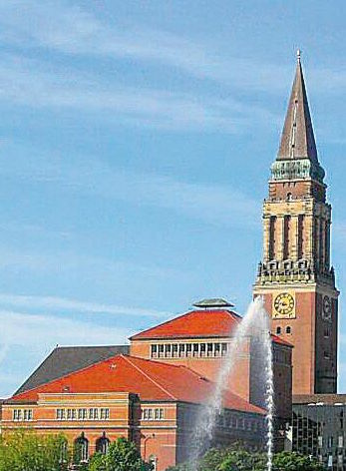  Kiel - The Sailing City |  |  | Industry standards in technical documentation  We primarily use Trados and Transit, for our translations. Other CAT tools may be supported on request. Naturally, all programs support the universal Translation Management eXchange format (TMX) to guarantee the quality of your translations and your valuable terminology databases.  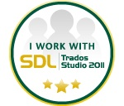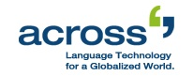 |  |  | Located in the beautiful sailing city of Kiel in the north of Germany.  20 years of experience within the translation industry, with customers in Germany, Austria, Switzerland, France, the UK, Holland and the US.  Services for a multilingual, global village …  Translation  Localization  Terminology management  Consultation

